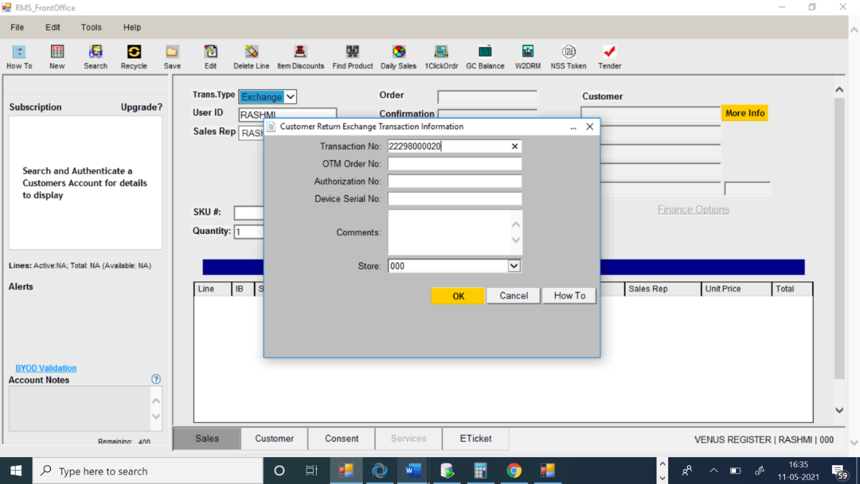

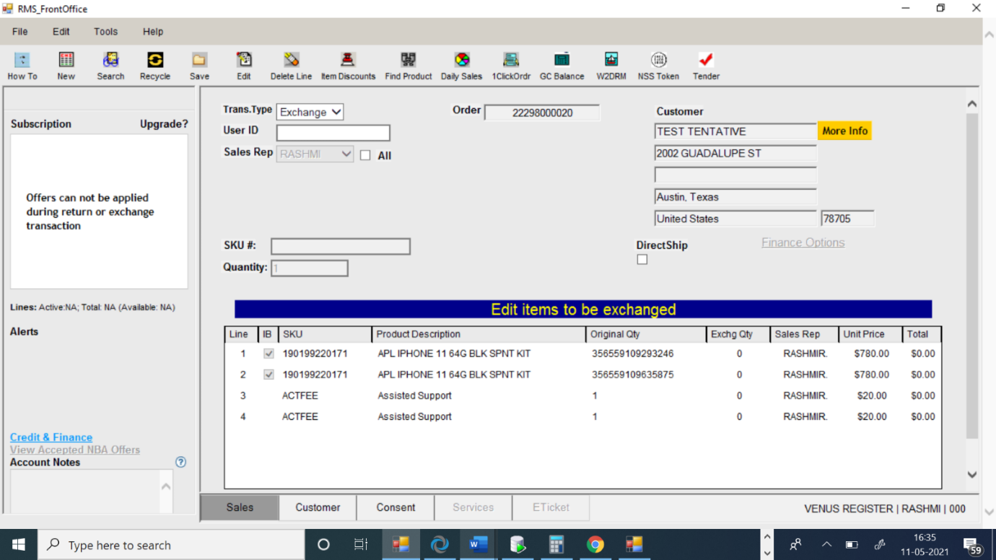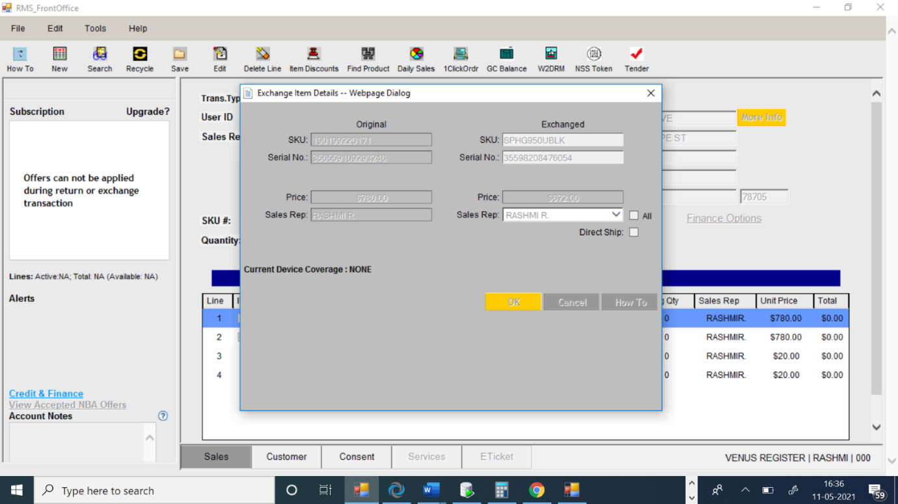

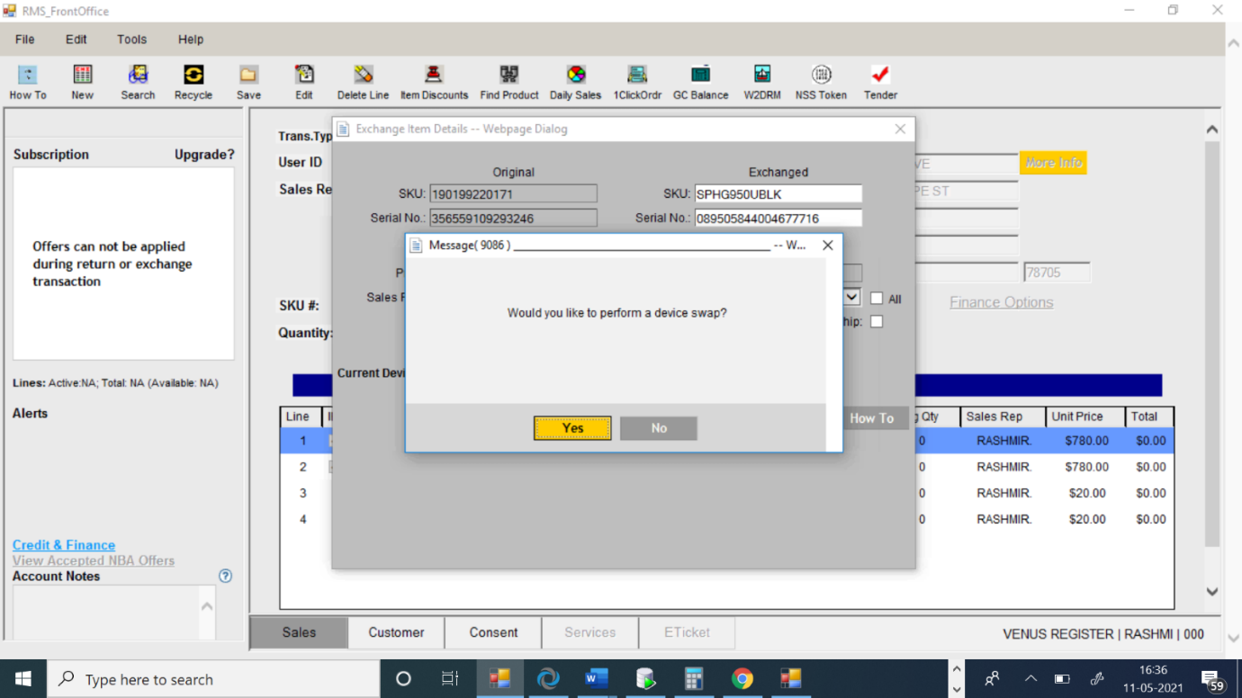

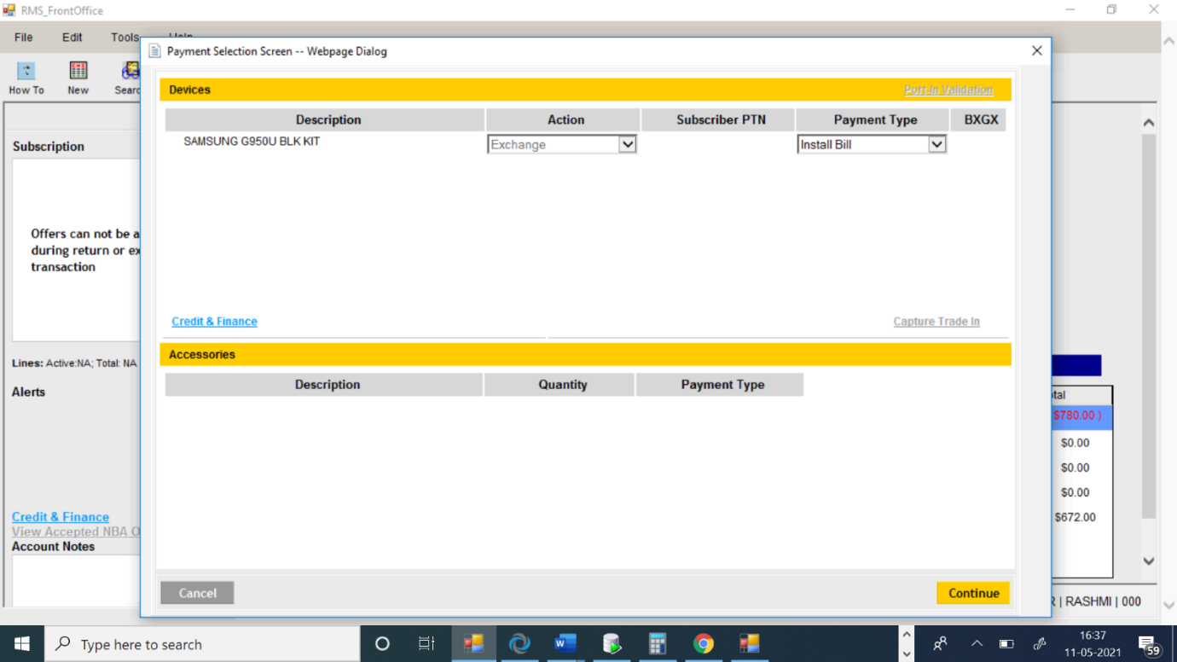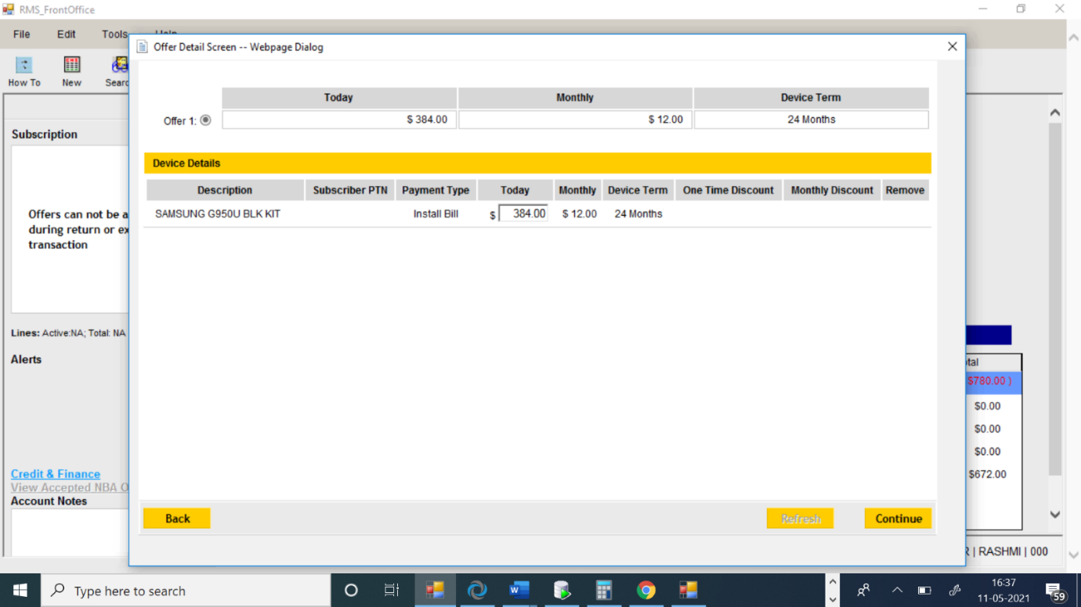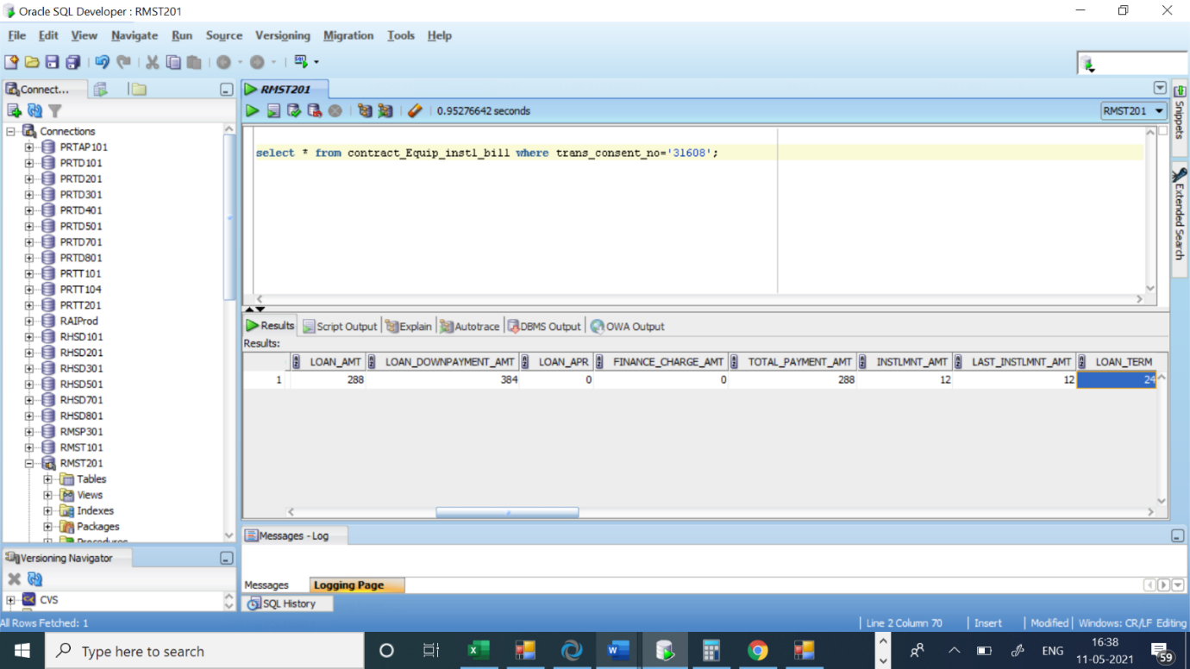

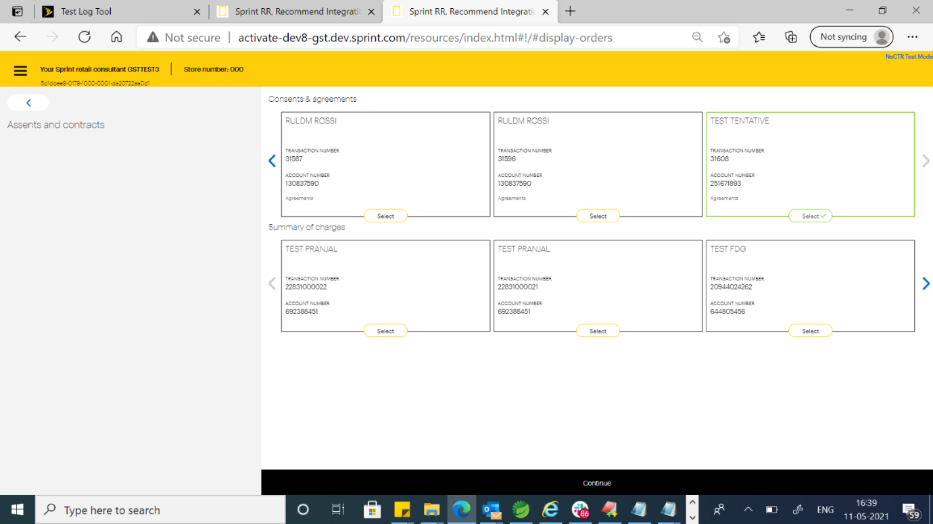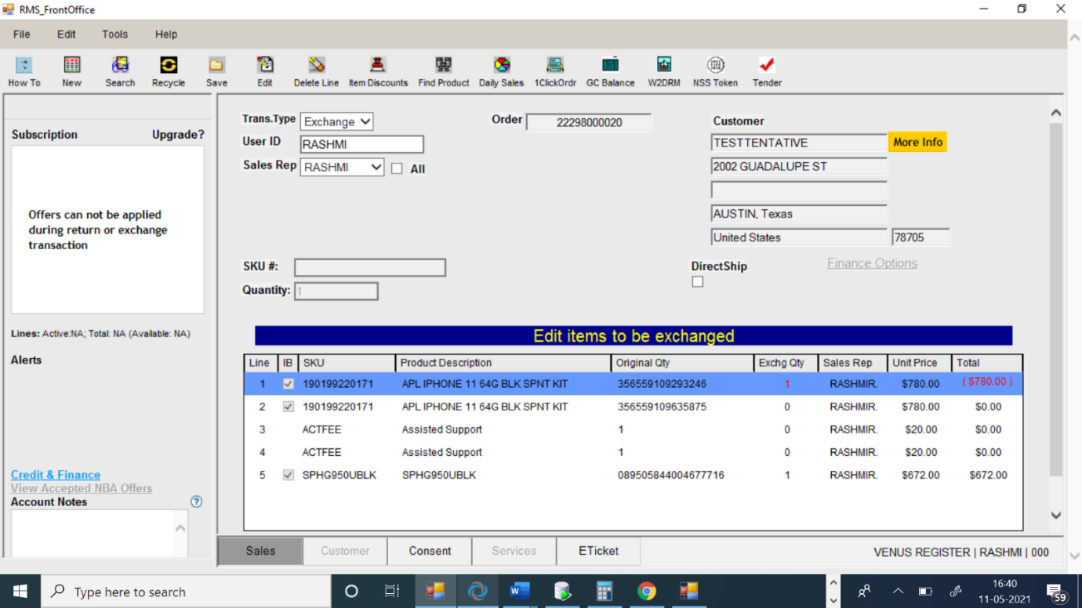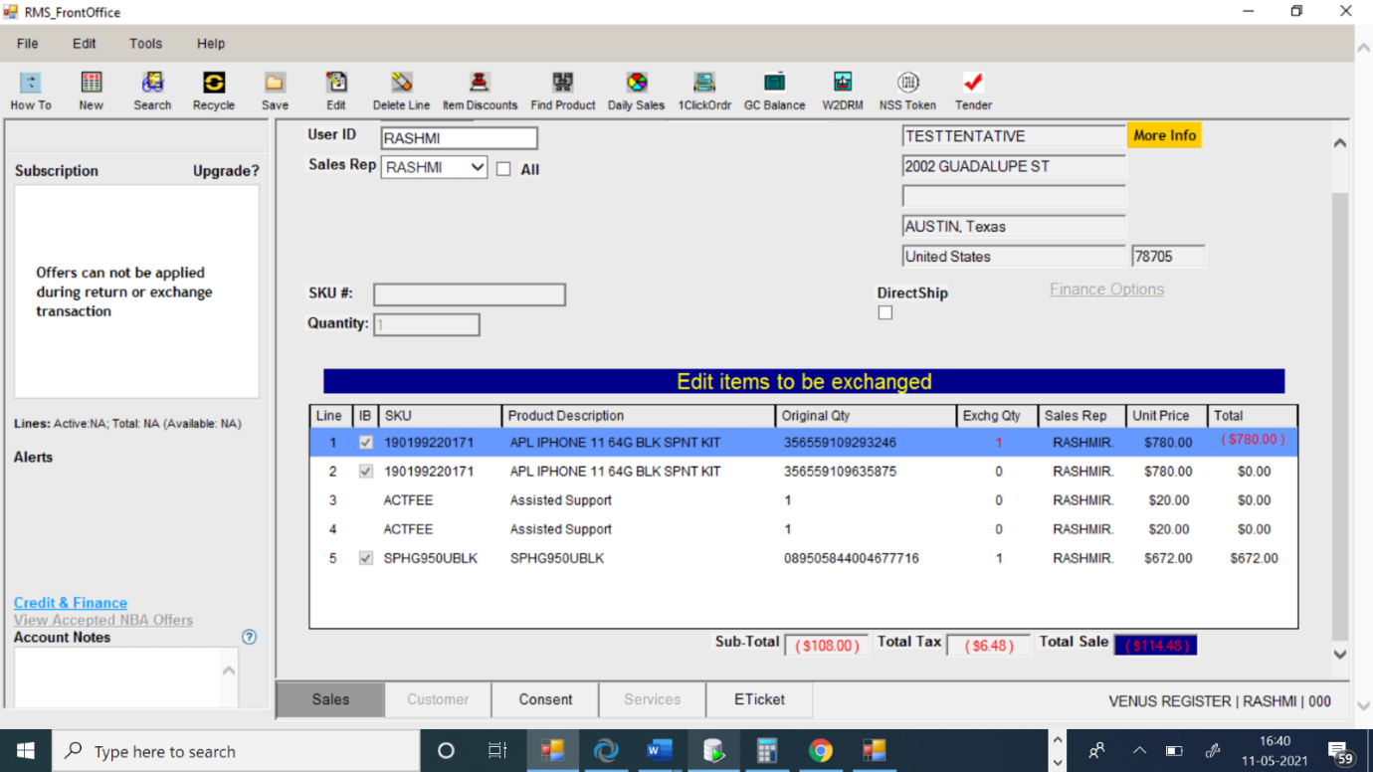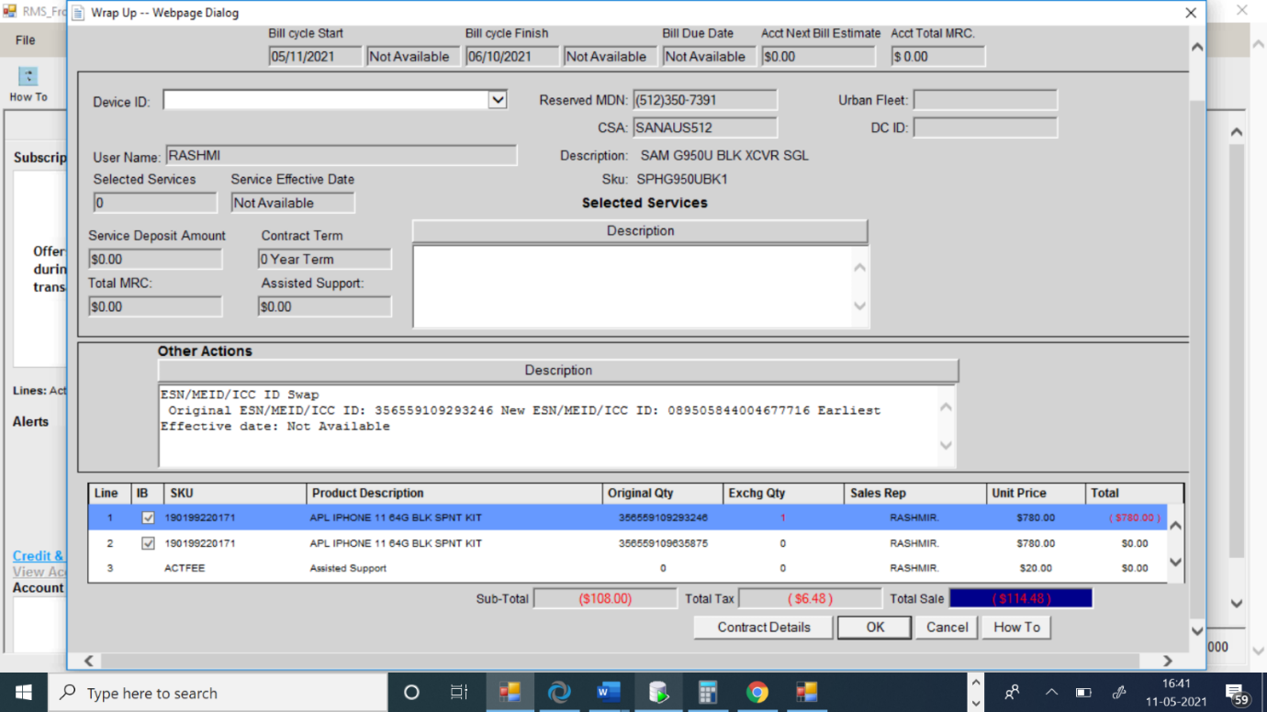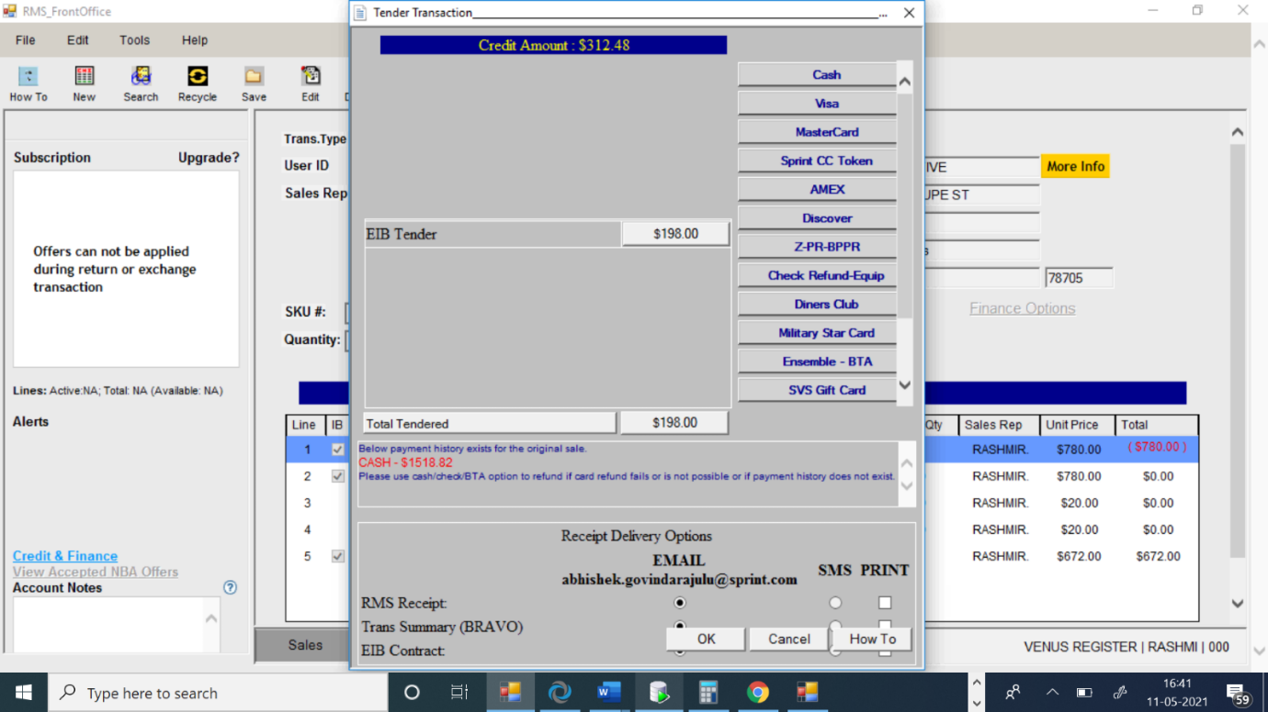

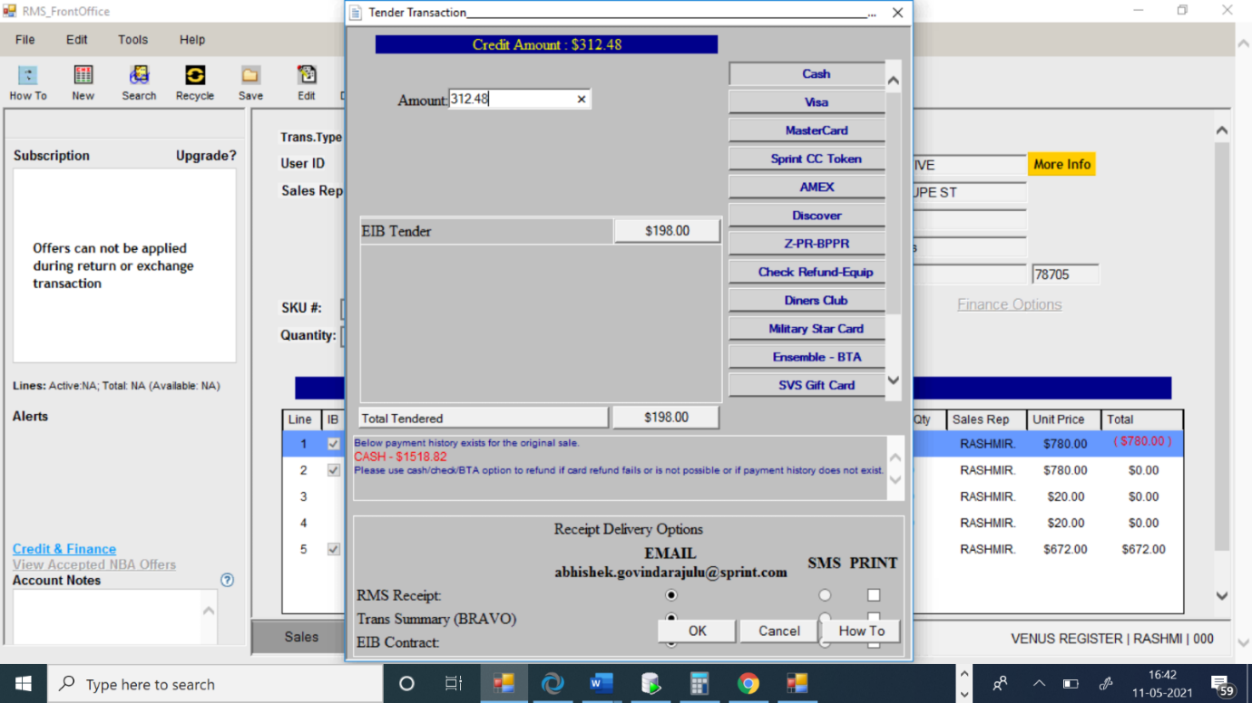

----------------------------------------------------------------------------------------

REQUEST:

20210511|07:07:48.171|RASHMI|XML Request for QueryFinancialOffersService

<?xml version='1.0' encoding='UTF-8'?>

<SOAP-ENV:Envelope xmlns:SOAP-ENV="http://schemas.xmlsoap.org/soap/envelope/" xmlns:xsi="http://www.w3.org/2001/XMLSchema-instance" xmlns:xsd="http://www.w3.org/2001/XMLSchema">

<SOAP-ENV:Header>

<tns:wsMessageHeader xmlns:tns="http://integration.sprint.com/common/header/WSMessageHeader/v2"><tns:trackingMessageHeader><tns:applicationId>RHS</tns:applicationId><tns:applicationUserId>System</tns:applicationUserId><tns:consumerId></tns:consumerId><tns:messageId>RHS:499080834</tns:messageId><tns:conversationId>3421</tns:conversationId><tns:timeToLive>45</tns:timeToLive><tns:messageDateTimeStamp>2021-05-11T07:07:46</tns:messageDateTimeStamp></tns:trackingMessageHeader></tns:wsMessageHeader>

</SOAP-ENV:Header>

<SOAP-ENV:Body>

<tns:queryFinancialOffers xmlns:tns="http://integration.sprint.com/interfaces/queryFinancialOffers/v1/queryFinancialOffers.xsd"><tns:accountInfo><tns:ban>251671893</tns:ban><tns:accountTypeInfo><tns:accountType>I</tns:accountType><tns:accountSubType>I</tns:accountSubType></tns:accountTypeInfo><tns:creditClass>H</tns:creditClass></tns:accountInfo><tns:orderInfo><tns:salesChannelInfo><tns:dealerCode>LAWND01X</tns:dealerCode></tns:salesChannelInfo><tns:equipmentItemList><tns:equipmentItemInfo><tns:contractType>1IB</tns:contractType><tns:equipmentLineId>5</tns:equipmentLineId><tns:itemId>SPHG950UBLK</tns:itemId><tns:srp>672.00</tns:srp><tns:quantity>1</tns:quantity><tns:equipmentType>D</tns:equipmentType><tns:additionalDownPayment>0.00</tns:additionalDownPayment><tns:orderLineType>ADD_ON</tns:orderLineType><tns:ibLeaseForClosureInfo><tns:continueBillingInd>false</tns:continueBillingInd><tns:deviceOptionCode>EX</tns:deviceOptionCode></tns:ibLeaseForClosureInfo></tns:equipmentItemInfo></tns:equipmentItemList><tns:discountQnAInfo><tns:zipCode>78705</tns:zipCode></tns:discountQnAInfo><tns:applyAddlPaymentDiscounts>true</tns:applyAddlPaymentDiscounts></tns:orderInfo><tns:fetchDiscountInfo>true</tns:fetchDiscountInfo><tns:geoLocationInfo><tns:dealerCode>LAWND01X</tns:dealerCode><tns:salesChannel>L</tns:salesChannel></tns:geoLocationInfo><tns:fetchAdditionalInfoList><tns:fetchAdditionalInfo><tns:fetchAdditionalInfoKey>OFFERGROUPINFO</tns:fetchAdditionalInfoKey></tns:fetchAdditionalInfo><tns:fetchAdditionalInfo><tns:fetchAdditionalInfoKey>FLEXPPO</tns:fetchAdditionalInfoKey></tns:fetchAdditionalInfo></tns:fetchAdditionalInfoList><tns:featureToggleInfoList><tns:featureToggleInfo><tns:featureToggleKey>EQUIPMENTMAC</tns:featureToggleKey></tns:featureToggleInfo><tns:featureToggleInfo><tns:featureToggleKey>APPLYORDERLINETYPE</tns:featureToggleKey></tns:featureToggleInfo></tns:featureToggleInfoList></tns:queryFinancialOffers>

</SOAP-ENV:Body>

</SOAP-ENV:Envelope>

RESPONSE:

20210511|07:07:48.171|RASHMI|XML Reply for QueryFinancialOffersService

<?xml version="1.0" encoding="UTF-8"?><SOAP-ENV:Envelope xmlns:SOAP-ENV="http://schemas.xmlsoap.org/soap/envelope/" xmlns:SOAP-ENC="http://schemas.xmlsoap.org/soap/encoding/" xmlns:xsi="http://www.w3.org/2001/XMLSchema-instance" xmlns:xsd="http://www.w3.org/2001/XMLSchema"><SOAP-ENV:Header><m:wsMessageHeader xmlns:m="http://integration.sprint.com/common/header/WSMessageHeader/v2"><m:trackingMessageHeader><m:applicationId>RHS</m:applicationId><m:applicationUserId>System</m:applicationUserId><m:consumerId/><m:messageId>RHS:499080834</m:messageId><m:conversationId>3421</m:conversationId><m:timeToLive>45</m:timeToLive><m:replyCompletionCode>0</m:replyCompletionCode><m:messageDateTimeStamp>2021-05-11T07:07:48-04:00</m:messageDateTimeStamp></m:trackingMessageHeader></m:wsMessageHeader></SOAP-ENV:Header><SOAP-ENV:Body><quer1:queryFinancialOffersResponse xmlns:quer="http://integration.sprint.com/integration/interfaces/queryFinancialOffersBtV1/v1/queryFinancialOffersBtV1" xmlns:quer1="http://integration.sprint.com/interfaces/queryFinancialOffers/v1/queryFinancialOffers.xsd">      <quer1:loanEligibilityInfo>        <quer1:accountType>I</quer1:accountType>        <quer1:accountSubType>I</quer1:accountSubType>        <quer1:loanEligibilityInd>true</quer1:loanEligibilityInd>        <quer1:accountLoanEligibilityInd>true</quer1:accountLoanEligibilityInd>        <quer1:creditClassEligibilityInd>true</quer1:creditClassEligibilityInd>        <quer1:geoLocationEligibilityInd>true</quer1:geoLocationEligibilityInd>        <quer1:loanMaxLimit>20</quer1:loanMaxLimit>        <quer1:equipmentOfferInfoList>          <quer1:financingOfferInfo>            <quer1:financingOfferId>266011A</quer1:financingOfferId>            <quer1:financingOfferRank>1</quer1:financingOfferRank>            <quer1:financingOfferItemInfoList>              <quer1:financingOfferItemInfo>                <quer1:orderLineItemNumber>5</quer1:orderLineItemNumber>                <quer1:itemId>SPHG950UBLK</quer1:itemId>                <quer1:itemIdEligibilityInd>true</quer1:itemIdEligibilityInd>                <quer1:contractType>1IB</quer1:contractType>                <quer1:contractTerm>24</quer1:contractTerm>                <quer1:srp>672.00</quer1:srp>                <quer1:itemCategoryDescription>SAMSUNG G950U BLK KIT</quer1:itemCategoryDescription>                <quer1:equipmentType>D</quer1:equipmentType>                <quer1:totalItemAmt>672.00</quer1:totalItemAmt>              </quer1:financingOfferItemInfo>            </quer1:financingOfferItemInfoList>            <quer1:totalAmt>672.00</quer1:totalAmt>          </quer1:financingOfferInfo>        </quer1:equipmentOfferInfoList>      </quer1:loanEligibilityInfo>    </quer1:queryFinancialOffersResponse></SOAP-ENV:Body></SOAP-ENV:Envelope>

----------------------------------------------------------------------------------------

REQUEST:

20210511|07:07:48.291|RASHMI|XML Request for QueryFinancialOffersCreditInfoService

<?xml version='1.0' encoding='UTF-8'?>

<SOAP-ENV:Envelope xmlns:SOAP-ENV="http://schemas.xmlsoap.org/soap/envelope/" xmlns:xsi="http://www.w3.org/2001/XMLSchema-instance" xmlns:xsd="http://www.w3.org/2001/XMLSchema">

<SOAP-ENV:Header>

<tns:wsMessageHeader xmlns:tns="http://integration.sprint.com/common/header/WSMessageHeader/v2"><tns:trackingMessageHeader><tns:applicationId>RHS</tns:applicationId><tns:applicationUserId>System</tns:applicationUserId><tns:consumerId></tns:consumerId><tns:messageId>RHS:590410432</tns:messageId><tns:conversationId>3421</tns:conversationId><tns:timeToLive>45</tns:timeToLive><tns:messageDateTimeStamp>2021-05-11T07:07:48</tns:messageDateTimeStamp></tns:trackingMessageHeader></tns:wsMessageHeader>

</SOAP-ENV:Header>

<SOAP-ENV:Body>

<tns:queryFinancialOffersCreditInfo xmlns:tns="http://integration.sprint.com/interfaces/queryFinancialOffersCreditInfo/v1/queryFinancialOffersCreditInfo.xsd"><tns:accountInfo><tns:ban>251671893</tns:ban><tns:creditClass>H</tns:creditClass></tns:accountInfo><tns:orderInfo><tns:salesChannelInfo><tns:dealerCode>LAWND01X</tns:dealerCode></tns:salesChannelInfo><tns:financingOfferInfo><tns:financingOfferId>266011A</tns:financingOfferId><tns:financingOfferItemInfoList><tns:financingOfferItemInfo><tns:orderLineItemNumber>5</tns:orderLineItemNumber><tns:orderLineType>EXCHANGE</tns:orderLineType><tns:itemId>SPHG950UBLK</tns:itemId><tns:contractType>1IB</tns:contractType><tns:quantity>1</tns:quantity><tns:contractTerm>24</tns:contractTerm><tns:srp>672.0</tns:srp><tns:equipmentType>D</tns:equipmentType><tns:ibLeaseForClosureInfo><tns:ibLeaseSeqNumber>57730190</tns:ibLeaseSeqNumber><tns:continueBillingInd>false</tns:continueBillingInd><tns:forgiveBalanceInd>true</tns:forgiveBalanceInd></tns:ibLeaseForClosureInfo><tns:origSalesTransDate>2021-05-11</tns:origSalesTransDate></tns:financingOfferItemInfo></tns:financingOfferItemInfoList></tns:financingOfferInfo><tns:fetchEstimatedSalesTaxInd>false</tns:fetchEstimatedSalesTaxInd></tns:orderInfo><tns:featureToggleInfoList><tns:featureToggleInfo><tns:featureToggleKey>EQUIPMENTMAC</tns:featureToggleKey></tns:featureToggleInfo><tns:featureToggleInfo><tns:featureToggleKey>APPLYORDERLINETYPE</tns:featureToggleKey></tns:featureToggleInfo></tns:featureToggleInfoList></tns:queryFinancialOffersCreditInfo>

</SOAP-ENV:Body>

</SOAP-ENV:Envelope>

RESPONSE:

20210511|07:07:48.292|RASHMI|XML Reply for QueryFinancialOffersCreditInfoService

<?xml version="1.0" encoding="UTF-8"?><SOAP-ENV:Envelope xmlns:SOAP-ENV="http://schemas.xmlsoap.org/soap/envelope/" xmlns:SOAP-ENC="http://schemas.xmlsoap.org/soap/encoding/" xmlns:xsi="http://www.w3.org/2001/XMLSchema-instance" xmlns:xsd="http://www.w3.org/2001/XMLSchema"><SOAP-ENV:Header><m:wsMessageHeader xmlns:m="http://integration.sprint.com/common/header/WSMessageHeader/v2"><m:trackingMessageHeader><m:applicationId>RHS</m:applicationId><m:applicationUserId>System</m:applicationUserId><m:consumerId/><m:messageId>RHS:590410432</m:messageId><m:conversationId>3421</m:conversationId><m:timeToLive>45</m:timeToLive><m:replyCompletionCode>0</m:replyCompletionCode><m:messageDateTimeStamp>2021-05-11T07:07:48-04:00</m:messageDateTimeStamp></m:trackingMessageHeader></m:wsMessageHeader></SOAP-ENV:Header><SOAP-ENV:Body><quer1:queryFinancialOffersCreditInfoResponse xmlns:quer="http://integration.sprint.com/integration/interfaces/queryFinancialOffersCreditInfoBtV1/v1/queryFinancialOffersCreditInfoBtV1" xmlns:quer1="http://integration.sprint.com/interfaces/queryFinancialOffersCreditInfo/v1/queryFinancialOffersCreditInfo.xsd">      <quer1:equipmentFinancingList>        <quer1:equipmentFinancingInfo>          <quer1:financingOfferId>266011A</quer1:financingOfferId>          <quer1:equipmentCreditLimitAmt>720.00</quer1:equipmentCreditLimitAmt>          <quer1:equipmentCreditBalanceAmt>630</quer1:equipmentCreditBalanceAmt>          <quer1:equipmentCreditAvailableAmt>810.00</quer1:equipmentCreditAvailableAmt>          <quer1:insufficientEquipmentCreditAmt>0</quer1:insufficientEquipmentCreditAmt>          <quer1:totalDownPaymentAmt>384.00</quer1:totalDownPaymentAmt>          <quer1:totalFinancedAmt>288.00</quer1:totalFinancedAmt>          <quer1:totalMonthlyPaymentAmt>12.00</quer1:totalMonthlyPaymentAmt>          <quer1:lineEquipmentFinancingList>            <quer1:lineEquipmentFinancingInfo>              <quer1:orderLineItemNumber>5</quer1:orderLineItemNumber>              <quer1:itemId>SPHG950UBLK</quer1:itemId>              <quer1:contractType>1IB</quer1:contractType>              <quer1:lineDownPaymentAmt>384.00</quer1:lineDownPaymentAmt>              <quer1:lineFinancedAmt>288.00</quer1:lineFinancedAmt>              <quer1:contractTerm>24</quer1:contractTerm>              <quer1:srp>672.0</quer1:srp>              <quer1:installmentAmt>12.00</quer1:installmentAmt>              <quer1:lastInstallmentAmt>12.00</quer1:lastInstallmentAmt>              <quer1:firstInstallmentDueDate>2021-06-11-05:00</quer1:firstInstallmentDueDate>              <quer1:lastInstallmentDueDate>2023-05-11-05:00</quer1:lastInstallmentDueDate>              <quer1:equipmentType>D</quer1:equipmentType>            </quer1:lineEquipmentFinancingInfo>          </quer1:lineEquipmentFinancingList>        </quer1:equipmentFinancingInfo>      </quer1:equipmentFinancingList>    </quer1:queryFinancialOffersCreditInfoResponse></SOAP-ENV:Body></SOAP-ENV:Envelope>

---------------------------------------------------------------------------

<quer1:orderLineItemNumber>5</quer1:orderLineItemNumber>              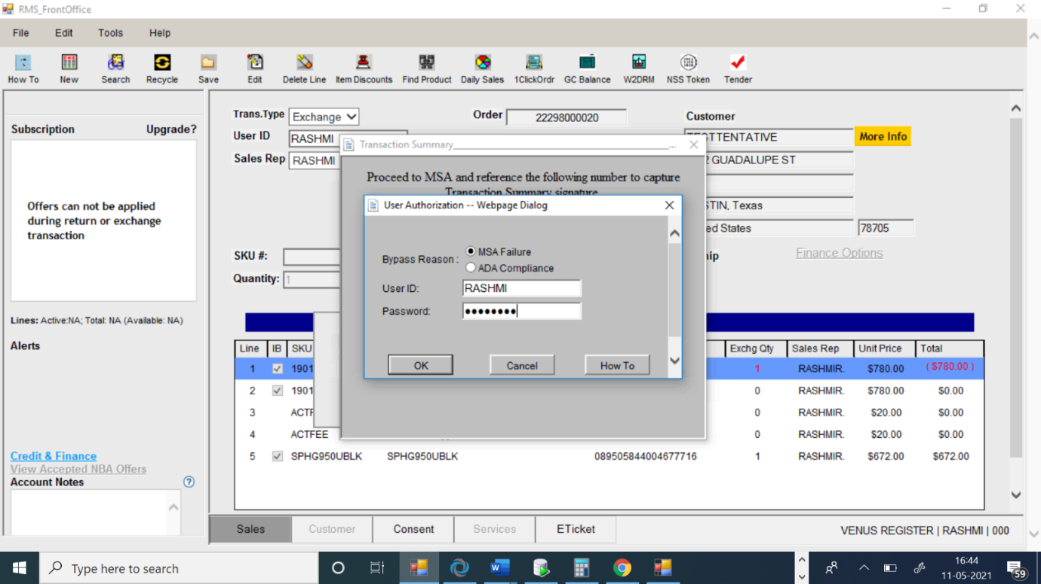<quer1:itemId>SPHG950UBLK</quer1:itemId>              <quer1:contractType>1IB</quer1:contractType>              <quer1:lineDownPaymentAmt>384.00</quer1:lineDownPaymentAmt>              <quer1:lineFinancedAmt>288.00</quer1:lineFinancedAmt>              <quer1:contractTerm>24</quer1:contractTerm>              <quer1:srp>672.0</quer1:srp>              <quer1:installmentAmt>12.00</quer1:installmentAmt>              <quer1:lastInstallmentAmt>12.00</quer1:lastInstallmentAmt>              <quer1:firstInstallmentDueDate>2021-06-11-05:00</quer1:firstInstallmentDueDate>              <quer1:lastInstallmentDueDate>2023-05-11-05:00</quer1:lastInstallmentDueDate>              <quer1:equipmentType>D</quer1:equipmentType>            </quer1:lineEquipmentFinancingInfo>          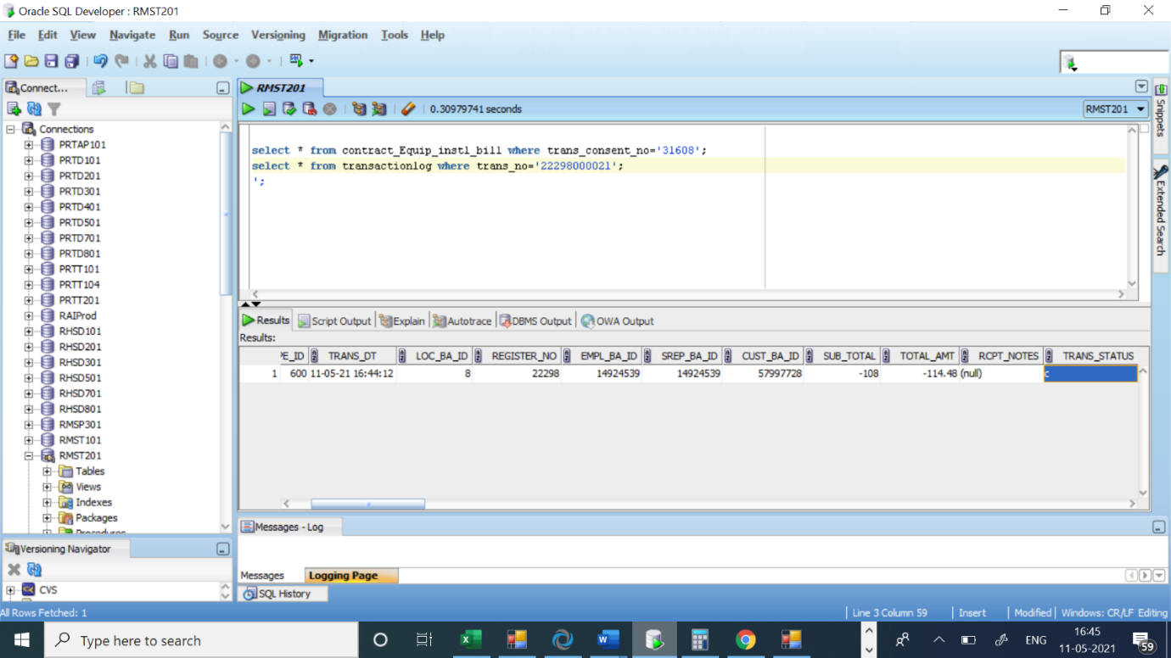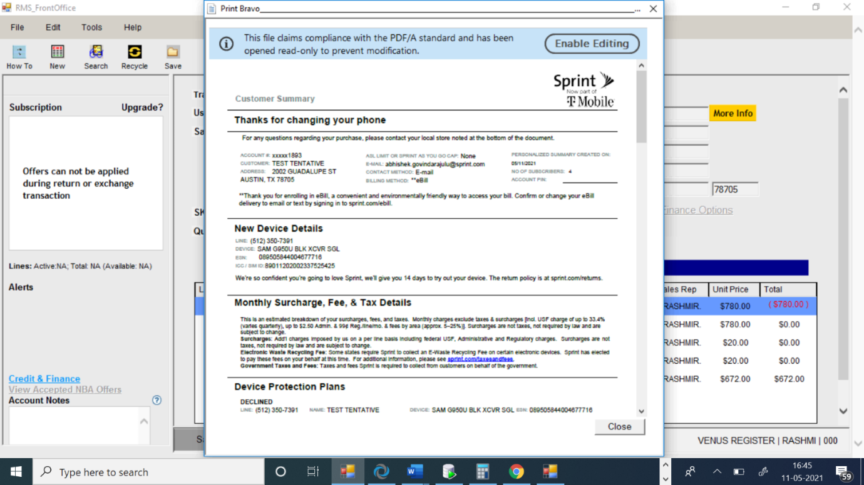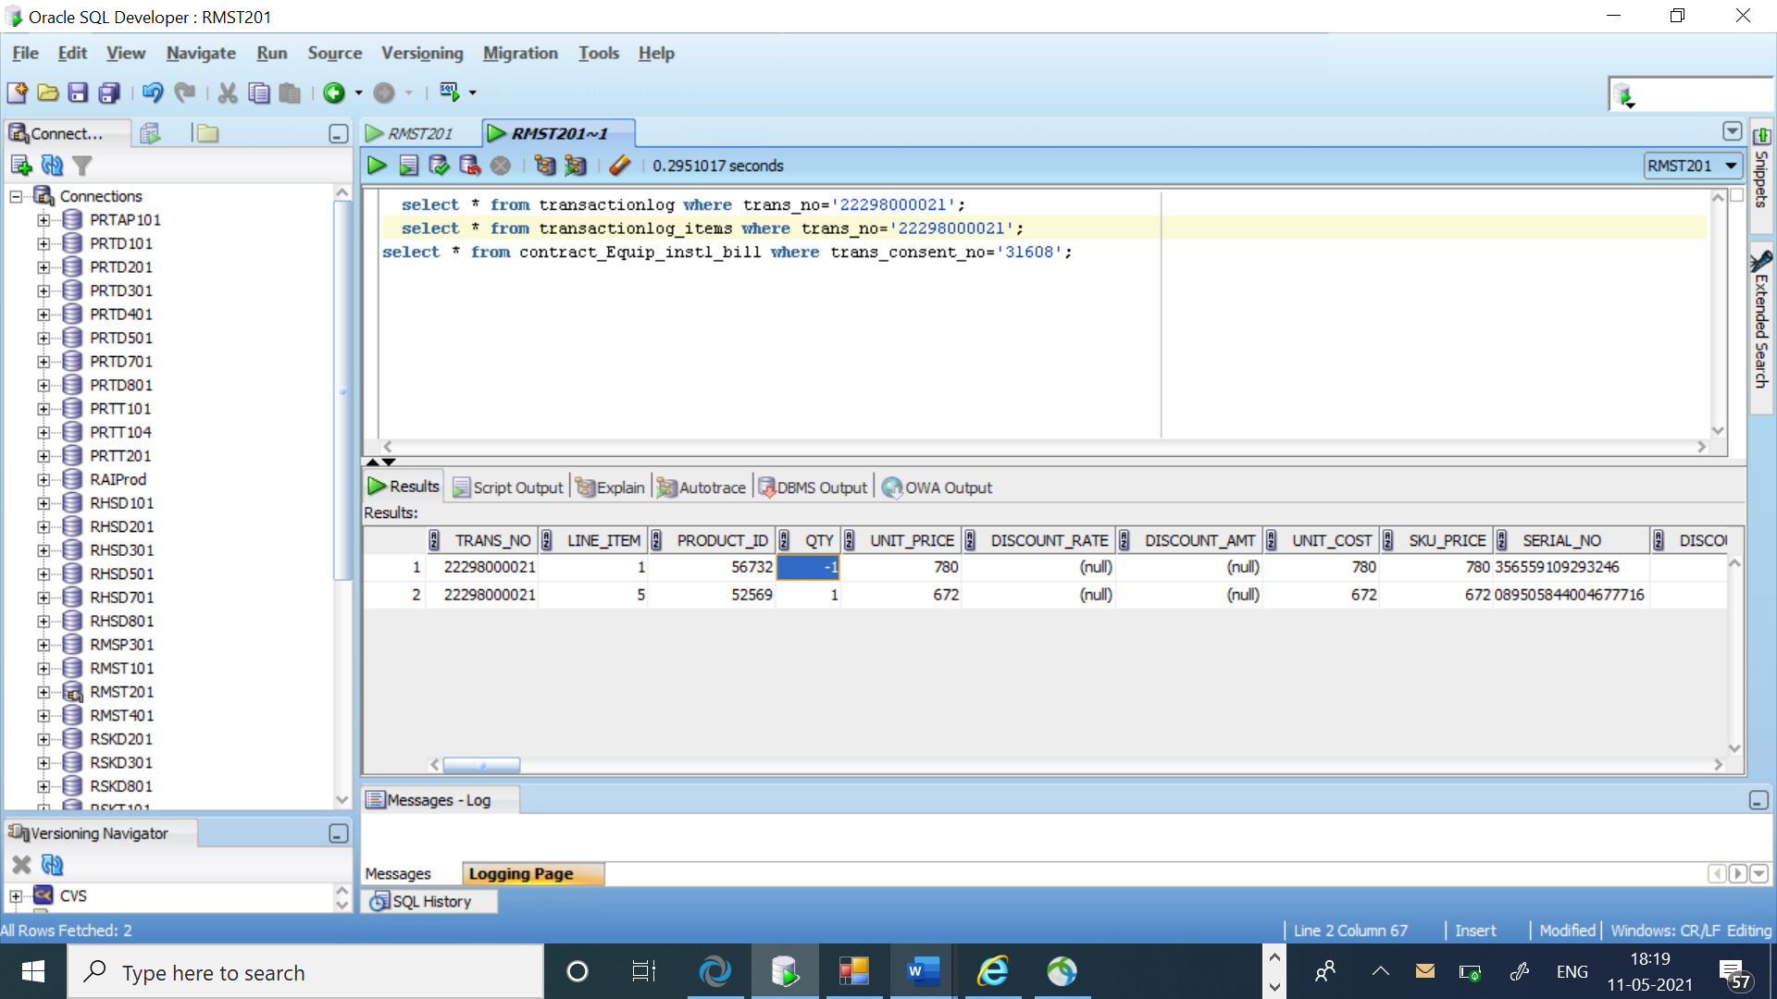

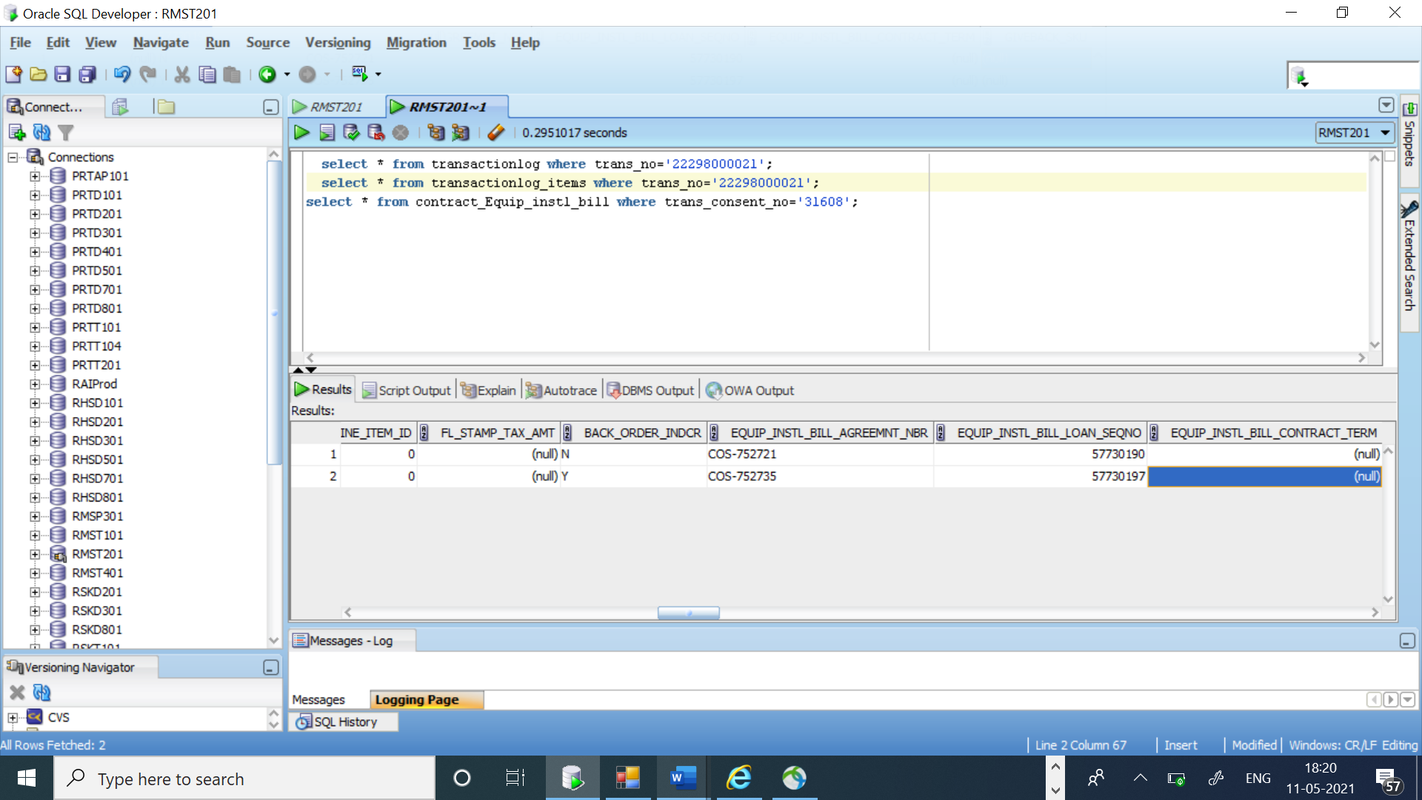</quer1:lineEquipmentFinancingList>        </quer1:equipmentFinancingInfo>      </quer1:equipmentFinancingList>    </quer1:queryFinancialOffersCreditInfoResponse></SOAP-ENV:Body></SOAP-ENV:Envelope>

20210511|07:14:22.028|RASHMI|XML Request for createLoan API

<?xml version='1.0' encoding='UTF-8'?>

<SOAP-ENV:Envelope xmlns:SOAP-ENV="http://schemas.xmlsoap.org/soap/envelope/" xmlns:xsi="http://www.w3.org/2001/XMLSchema-instance" xmlns:xsd="http://www.w3.org/2001/XMLSchema">

<SOAP-ENV:Header>

<tns:wsMessageHeader xmlns:tns="http://integration.sprint.com/common/header/WSMessageHeader/v2"><tns:trackingMessageHeader><tns:applicationId>RHS</tns:applicationId><tns:applicationUserId>System</tns:applicationUserId><tns:consumerId></tns:consumerId><tns:messageId>RHS:57190934</tns:messageId><tns:conversationId>3421</tns:conversationId><tns:timeToLive>45</tns:timeToLive><tns:messageDateTimeStamp>2021-05-11T07:14:21</tns:messageDateTimeStamp></tns:trackingMessageHeader></tns:wsMessageHeader>

</SOAP-ENV:Header>

<SOAP-ENV:Body>

<tns:createLoan xmlns:tns="http://integration.sprint.com/interfaces/createLoan/v1/createLoan.xsd"><tns:accountInfo><tns:subscriberId>45084610221</tns:subscriberId></tns:accountInfo><tns:loanInfo><tns:loanNumber>COS-752735</tns:loanNumber><tns:subscriberId>45084610221</tns:subscriberId><tns:loanDate>2021-05-11</tns:loanDate><tns:downPaymentAmount>384</tns:downPaymentAmount><tns:loanAmountFinanced>288</tns:loanAmountFinanced><tns:loanTerm>24</tns:loanTerm><tns:dealerCode>LAWND01X</tns:dealerCode><tns:transactionId>22298000021</tns:transactionId><tns:transactionDate>2021-05-11T07:14:21Z</tns:transactionDate><tns:installmentAmount>12</tns:installmentAmount><tns:previousInstallmentAmount>12</tns:previousInstallmentAmount><tns:loanType>D</tns:loanType><tns:loanModel>S</tns:loanModel><tns:loanItemsList><tns:loanItemsInfo><tns:itemId>SPHG950UBK1</tns:itemId><tns:quantity>1</tns:quantity><tns:downPaymentAmount>384</tns:downPaymentAmount><tns:loanAmount>288</tns:loanAmount><tns:transactionLineNumber>5</tns:transactionLineNumber><tns:deviceSerialNumber>089505844004677716</tns:deviceSerialNumber></tns:loanItemsInfo></tns:loanItemsList><tns:contractType>I</tns:contractType></tns:loanInfo></tns:createLoan>

</SOAP-ENV:Body>

</SOAP-ENV:Envelope>

RESPONSE:

20210511|07:14:22.028|RASHMI|XML Reply for createLoan API

<?xml version="1.0" encoding="UTF-8"?><SOAP-ENV:Envelope xmlns:SOAP-ENV="http://schemas.xmlsoap.org/soap/envelope/" xmlns:SOAP-ENC="http://schemas.xmlsoap.org/soap/encoding/" xmlns:xsi="http://www.w3.org/2001/XMLSchema-instance" xmlns:xsd="http://www.w3.org/2001/XMLSchema"><SOAP-ENV:Header><m:wsMessageHeader xmlns:m="http://integration.sprint.com/common/header/WSMessageHeader/v2"><m:trackingMessageHeader><m:applicationId>RHS</m:applicationId><m:applicationUserId>System</m:applicationUserId><m:consumerId/><m:messageId>RHS:57190934</m:messageId><m:conversationId>3421</m:conversationId><m:timeToLive>45</m:timeToLive><m:replyCompletionCode>0</m:replyCompletionCode><m:messageDateTimeStamp>2021-05-11T07:14:21-04:00</m:messageDateTimeStamp></m:trackingMessageHeader></m:wsMessageHeader></SOAP-ENV:Header><SOAP-ENV:Body><cre1:createLoanResponse xmlns:cre1="http://integration.sprint.com/interfaces/createLoan/v1/createLoan.xsd" xmlns:cre="http://integration.sprint.com/integration/interfaces/createLoanBtV1/v1/createLoanBtV1"> <cre1:loanSequenceNumber>57730197</cre1:loanSequenceNumber> <cre1:loanLastCycleCloseDate>2023-05-10</cre1:loanLastCycleCloseDate> </cre1:createLoanResponse></SOAP-ENV:Body></SOAP-ENV:Envelope>

----------------------------------------------------------------------------------------

REQUEST:

RESPONSE:

20210511|07:14:22.776|RASHMI|UpdatePOSTransactionRequest

<UpdatePOSTransactionRequest>

<header>

<storeIdentifier>8</storeIdentifier>

<applIdentifier>RMS</applIdentifier>

<rmsUserIdentifier>RASHMI</rmsUserIdentifier>

<applUserIdentifier>RMS</applUserIdentifier>

<applUserPwd>RMS</applUserPwd>

<____hashCodeCalc>false</____hashCodeCalc>

</header>

<____hashCodeCalc defined-in="com.wsclasses.Request">false</____hashCodeCalc>

<prepaidIndicator>false</prepaidIndicator>

<accessoryOnlyIndicator>false</accessoryOnlyIndicator>

<updateTransaction>

<updateTransactionTimeInfo>

<transactionNumber>22298000021</transactionNumber>

<startDateTime>2021-05-11T07:05:42</startDateTime>

<finishDateTime>2021-05-11T07:14:22</finishDateTime>

<____hashCodeCalc>false</____hashCodeCalc>

</updateTransactionTimeInfo>

<updateTransactionServicesList>

<updateTransactionServicesInfo>

<com.wsclasses.UpdateTransactionServicesInfo>

<serviceType>esnswap</serviceType>

<esn>356559109293246</esn>

<swapToEsn>089505844004677716</swapToEsn>

<mdn>5123507391</mdn>

<effectiveDate>2021-05-11T07:14:22</effectiveDate>

<courtesyAdjustmentAmount>0.0</courtesyAdjustmentAmount>

<quantity>0</quantity>

<mrc>0.0</mrc>

<contractIdentifier>51927751</contractIdentifier>

<walkIn>0</walkIn>

<swapToWalkIn>0</swapToWalkIn>

<status>0</status>

<service3GFlag>y</service3GFlag>

<subscriberIdentifier>45084610221</subscriberIdentifier>

<deviceType>D</deviceType>

<flipFlopIndicator>n</flipFlopIndicator>

<armRebateIdentifier>216520164-99</armRebateIdentifier>

<accountNumber>251671893</accountNumber>

<storeIdentifier>8</storeIdentifier>

<customerIdentifier>57997728</customerIdentifier>

<employeeIdentifier>14924539</employeeIdentifier>

<sku>SPHG950UBK1</sku>

<flStampTaxAmount>0.0</flStampTaxAmount>

<equipmentInstallBillLeaseInfo>

<equipmentInstallmentTypeIndicator>0</equipmentInstallmentTypeIndicator>

<downpaymentAmount>384.0</downpaymentAmount>

<contractTerm>24</contractTerm>

<equipmentInstallBillTaxAmount>0.0</equipmentInstallBillTaxAmount>

<equipmentInstallBillLoanContractNumber>COS-752735</equipmentInstallBillLoanContractNumber>

<loanMonthlyPaymentAmount>12.0</loanMonthlyPaymentAmount>

<additionalDownpaymentAmount>0.0</additionalDownpaymentAmount>

<equipmentLoanSequenceNumber>57730197</equipmentLoanSequenceNumber>

<leaseInfo>

<residualLeaseAmount>0.0</residualLeaseAmount>

<____hashCodeCalc>false</____hashCodeCalc>

</leaseInfo>

<equipmentInstallBillAgreementNumber>COS-752735</equipmentInstallBillAgreementNumber>

<____hashCodeCalc>false</____hashCodeCalc>

</equipmentInstallBillLeaseInfo>

<transactionServicesDetails>

<lineItemNumber>1</lineItemNumber>

<planCode>PDSI3PP</planCode>

<planDescription>Unl Talk/Text-Open Lease Only</planDescription>

<____hashCodeCalc>false</____hashCodeCalc>

</transactionServicesDetails>

<rowNumber>0</rowNumber>

<earlyUpgradeTradeInInfo>

<____hashCodeCalc>false</____hashCodeCalc>

</earlyUpgradeTradeInInfo>

<devicePurchaseType>EP</devicePurchaseType>

<lineItemNumber>5</lineItemNumber>

<____hashCodeCalc>false</____hashCodeCalc>

</com.wsclasses.UpdateTransactionServicesInfo>

</updateTransactionServicesInfo>

<____hashCodeCalc>false</____hashCodeCalc>

</updateTransactionServicesList>

<updateOmimOrderList>

<updateOmimOrderInfo>

<com.wsclasses.UpdateOmimOrderInfo>

<lineItemNumber>1</lineItemNumber>

<backorderIndicator>N</backorderIndicator>

<serviceExchangeCode>n</serviceExchangeCode>

<____hashCodeCalc>false</____hashCodeCalc>

</com.wsclasses.UpdateOmimOrderInfo>

<com.wsclasses.UpdateOmimOrderInfo>

<lineItemNumber>5</lineItemNumber>

<backorderIndicator>Y</backorderIndicator>

<serviceExchangeCode>n</serviceExchangeCode>

<____hashCodeCalc>false</____hashCodeCalc>

</com.wsclasses.UpdateOmimOrderInfo>

</updateOmimOrderInfo>

<____hashCodeCalc>false</____hashCodeCalc>

</updateOmimOrderList>

<updateCustomerAccountInfo>

<billCycleStartDate>2021-05-11</billCycleStartDate>

<billCycleEndDate>2021-06-10</billCycleEndDate>

<newCustomerIndicator>N</newCustomerIndicator>

<____hashCodeCalc>false</____hashCodeCalc>

</updateCustomerAccountInfo>

<transactionAddOnDetailsList>

<transactionAddOnDetailsInfo>

<com.wsclasses.TransactionAddOnDetailsInfo>

<serviceLineNo>2</serviceLineNo>

<serviceCode>PDSI3DAT</serviceCode>

<esn>356559109293246</esn>

<serviceDescription>1GB 3G/4G Data Adj Speed</serviceDescription>

<____hashCodeCalc>false</____hashCodeCalc>

</com.wsclasses.TransactionAddOnDetailsInfo>

<com.wsclasses.TransactionAddOnDetailsInfo>

<serviceLineNo>3</serviceLineNo>

<serviceCode>REQLPRO</serviceCode>

<esn>356559109293246</esn>

<serviceDescription>LTE Provisioning</serviceDescription>

<____hashCodeCalc>false</____hashCodeCalc>

</com.wsclasses.TransactionAddOnDetailsInfo>

<com.wsclasses.TransactionAddOnDetailsInfo>

<serviceLineNo>4</serviceLineNo>

<serviceCode>NOXPTMVMO</serviceCode>

<esn>356559109293246</esn>

<serviceDescription>T-Mobile Voicemail</serviceDescription>

<____hashCodeCalc>false</____hashCodeCalc>

</com.wsclasses.TransactionAddOnDetailsInfo>

</transactionAddOnDetailsInfo>

<____hashCodeCalc>false</____hashCodeCalc>

</transactionAddOnDetailsList>

<updateeibloaninfoList>

<updateeibloaninfo>

<com.wsclasses.Updateeibloaninfo>

<serialNo>089505844004677716</serialNo>

<instlBillSeqNo>57730197</instlBillSeqNo>

<deviceType>D</deviceType>

<____hashCodeCalc>false</____hashCodeCalc>

</com.wsclasses.Updateeibloaninfo>

</updateeibloaninfo>

<____hashCodeCalc>false</____hashCodeCalc>

</updateeibloaninfoList>

<____hashCodeCalc>false</____hashCodeCalc>

</updateTransaction>

<____hashCodeCalc>false</____hashCodeCalc>

</UpdatePOSTransactionRequest>

----------------------------------------------------------------------------------------

REQUEST:

RESPONSE:

20210511|07:14:22.776|RASHMI|UpdatePOSTransactionResponse

<UpdatePOSTransactionResponse>

<header>

<____hashCodeCalc>false</____hashCodeCalc>

</header>

<____hashCodeCalc defined-in="com.wsclasses.Response">false</____hashCodeCalc>

<transactionNumber>22298000021</transactionNumber>

<returnValue>0</returnValue>

<____hashCodeCalc>false</____hashCodeCalc>

</UpdatePOSTransactionResponse>

20210511|07:14:14.696|tvmkb141.test.sprint.com|CALL|RET01A2T|AMD.ARM.APPLY_REBATE|RASHMI|0|[B@56f9f|158

20210511|07:14:14.697|tvmkb141.test.sprint.com|PROCESS|XXXX|AMD.ARM.APPLY_REBATE|RASHMI|0|RHS:xxxxxxxxx|0|159

20210511|07:14:20.872|tvmkb141.test.sprint.com|CALL|RET01A2T|AMD.ENSEMBLE.UPD_SUB_EQUP|RASHMI|0|[B@28e5fccd|6171

20210511|07:14:20.873|tvmkb141.test.sprint.com|PROCESS|XXXX|AMD.ENSEMBLE.UPD_SUB_EQUP|RASHMI|0|RHS:xxxxxxxxx|0|6175

20210511|07:14:21.205|tvmkb141.test.sprint.com|CALL|searchLoan|RASHMI|0|RHS:814985185|331

20210511|07:14:21.207|tvmkb141.test.sprint.com|PROCESS|searchLoan|RASHMI|0|RHS:814985185|0|332

20210511|07:14:21.644|tvmkb141.test.sprint.com|CALL|updateLoan|RASHMI|0|RHS:246613270|435

20210511|07:14:21.644|tvmkb141.test.sprint.com|PROCESS|updateLoan|RASHMI|0|RHS:246613270|0|436

20210511|07:14:22.027|tvmkb141.test.sprint.com|CALL|createLoan|RASHMI|0|RHS:228031520|381

20210511|07:14:22.028|tvmkb141.test.sprint.com|PROCESS|createLoan|RASHMI|0|RHS:228031520|0|382

20210511|07:14:22.776|tvmkb141.test.sprint.com|CALL|UpdatePOSTransaction|RASHMI|0|RHS|1620731662776

20210511|07:14:22.776|tvmkb141.test.sprint.com|PROCESS|UpdatePOSTransaction|RASHMI|0|RHS|0|1620731662776

2